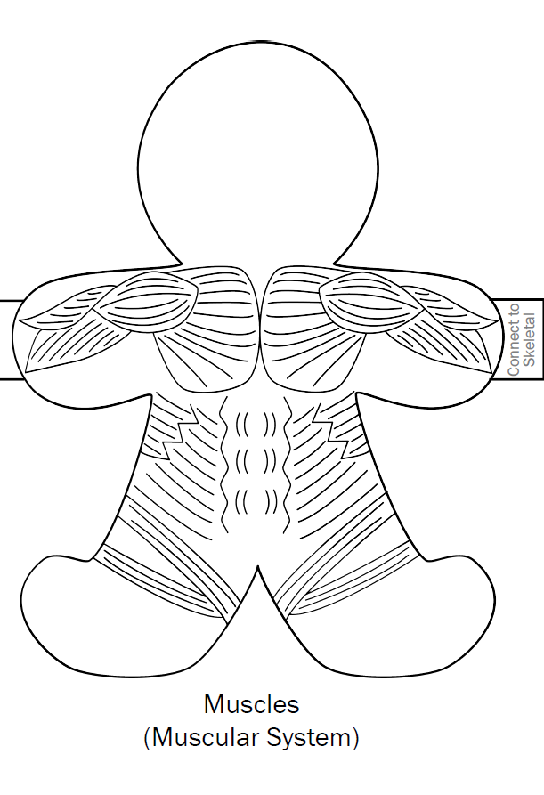 | Major Organs
Organ System Teamwork

System | How it interacts

Function & Purpose
________________________________
________________________________
________________________________
________________________________
________________________________
________________________________
________________________________
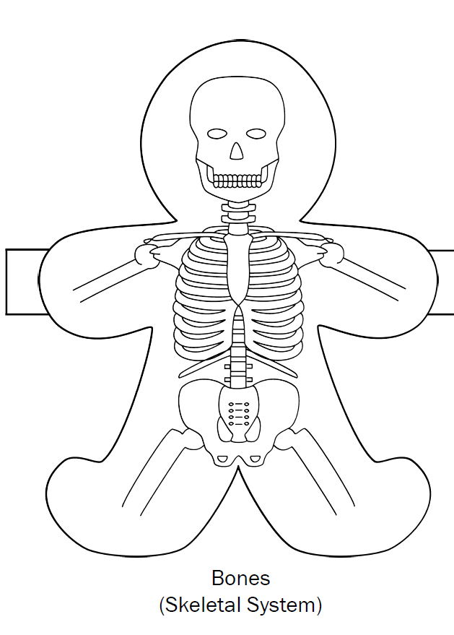 | Major Organs
Organ System Teamwork

System | How it interacts

Function & Purpose
________________________________
________________________________
________________________________
________________________________
________________________________
________________________________
________________________________
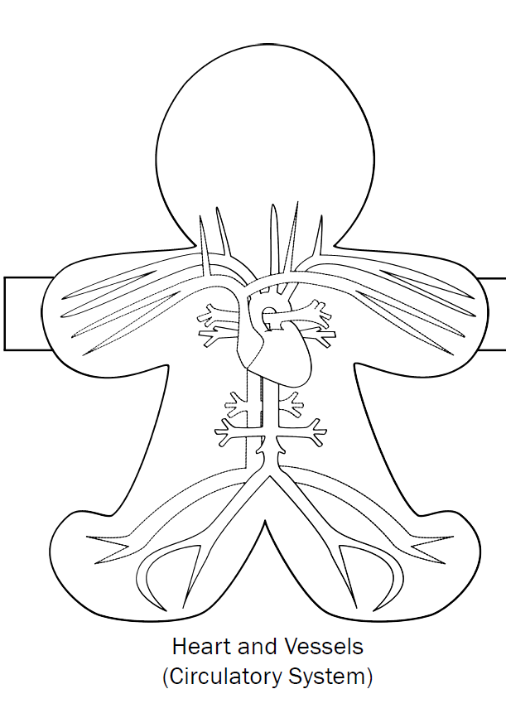 | Major Organs  Color Organ Name
Organ System Teamwork

System | How it interacts

Function & Purpose
________________________________
________________________________
________________________________
________________________________
________________________________
________________________________
________________________________
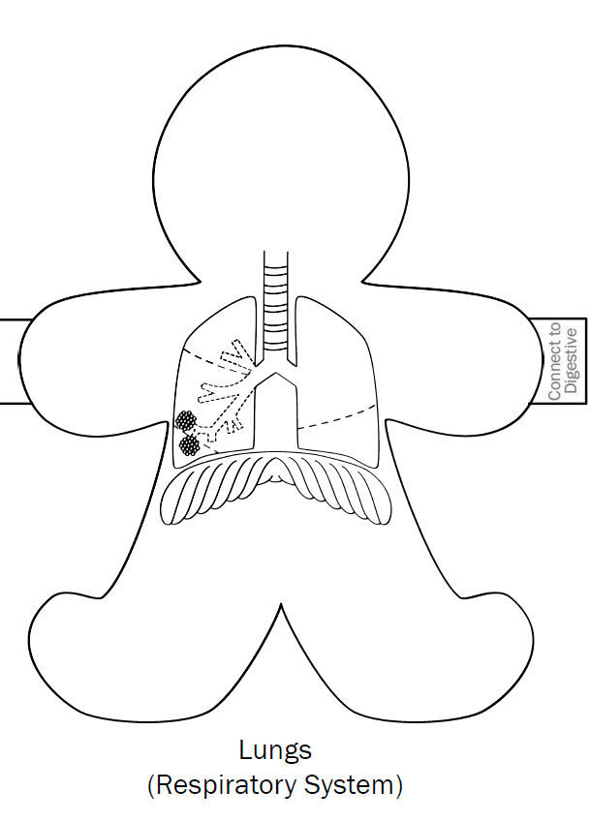 | Major Organs  Color Organ Name
Organ System Teamwork

System | How it interacts

Function & Purpose
________________________________
________________________________
________________________________
________________________________
________________________________
________________________________
________________________________
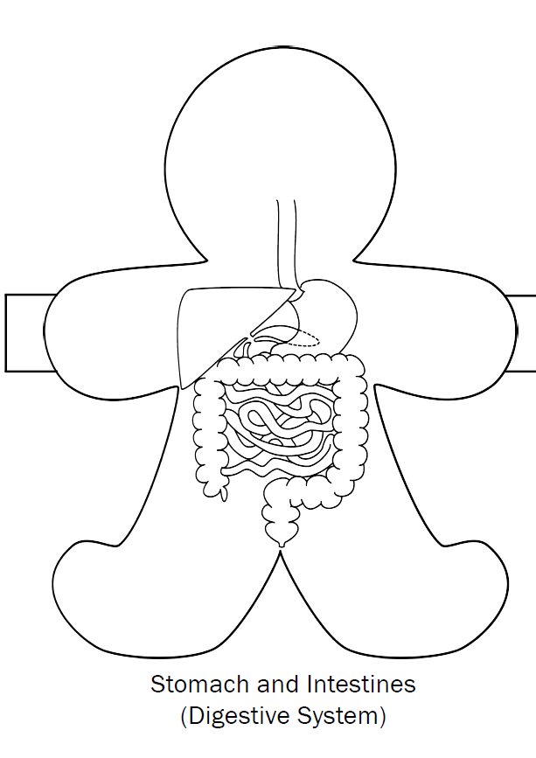 | Major Organs  Color Organ Name
Organ System Teamwork

System | How it interacts

Function & Purpose
________________________________
________________________________
________________________________
________________________________
________________________________
________________________________
________________________________
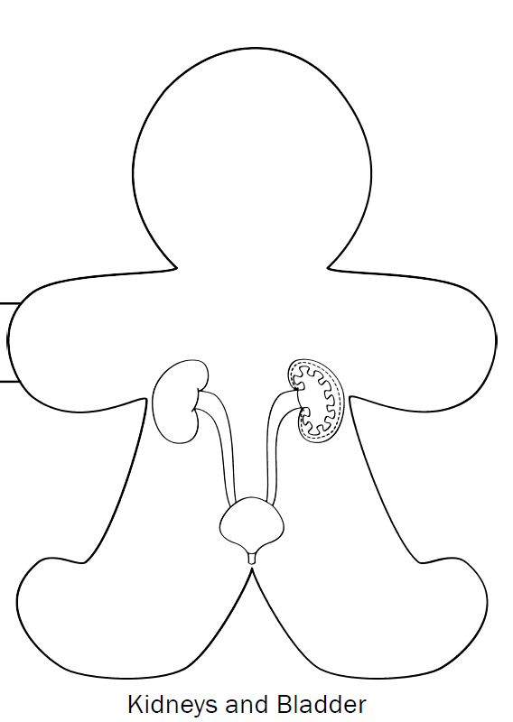 | Major Organs  Color Organ Name
Organ System Teamwork

System | How it interacts

Function & Purpose
________________________________
________________________________
________________________________
________________________________
________________________________
________________________________
________________________________
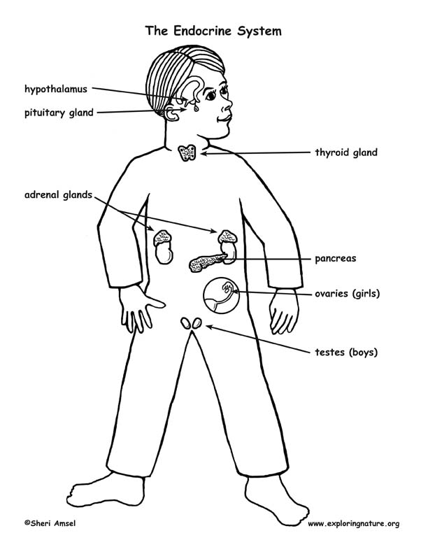 | Major Organs  Color Organ Name
Organ System Teamwork

System | How it interacts

Function & Purpose
________________________________
________________________________
________________________________
________________________________
________________________________
________________________________
________________________________
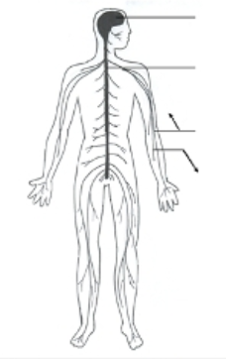 | Major Organs  Color Organ Name
Organ System Teamwork

System | How it interacts

Function & Purpose
________________________________
________________________________
________________________________
________________________________
________________________________
________________________________
________________________________
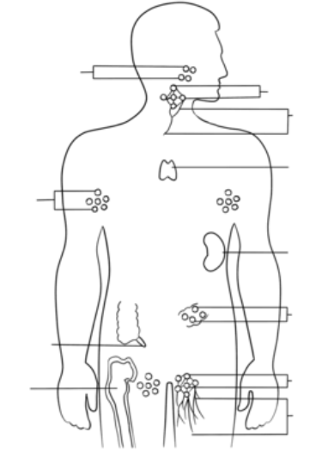  _________________________________  Function & Purpose  ________________________________  ________________________________  ________________________________  ________________________________  ________________________________  ________________________________  ________________________________ | Major Organs  Color Organ Name
Organ System Teamwork

System | How it interacts

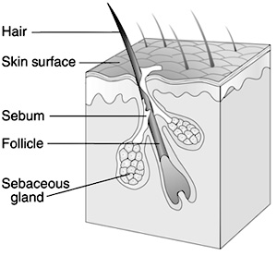  __________________________________________  Function & Purpose  ________________________________  ________________________________  ________________________________  ________________________________  ________________________________  ________________________________  ________________________________ | Major Organs  Color Organ Name
Organ System Teamwork

System | How it interacts

